Transportation System

Version 1.0

April 29, 2024

Abdelrahman Mostafa Darwish

Amr Mohamed Shalaby

Mohamed El-Sayed Attia

Mohamed Abdelmagid Rabea

Mohamed Magdy Teba

Rawan Hamdy Yahia

Shahd Saeed El-Katsha

1. **Introduction**

*1.1 Purpose*

An organization wants a system to use the transportation in the country in a more defined method.

*1.2 Scope*

## **Bus Stop Management System with Ticketing (Scope Example)**

**Project:** Developing a Bus Stop Management System

**Scope Definition:**

* **Goals:**
  + Improve passenger experience at bus stops by reducing waiting times and queues.
  + Increase efficiency in fare collection and ridership tracking.
  + Provide real-time bus arrival information and potential delays.
* **Deliverables:**
  + A web application and mobile app for ticket purchase and information access.
  + Integration with a central ticketing system for managing fares, accounts, and transactions.
  + Real-time bus tracking software displaying estimated arrival times at each stop.
  + Secure passenger information storage and data management system.
* **Timeline:** 1 year for development and pilot implementation at selected bus stops, followed by a phased rollout across the Country.
* **Budget:** 100k for software development, system integration, and initial maintenance.
* **Resources:** Software developers, system integrators, data security specialists, data analytics.

**Important to exclude from scope (for this example):**

* Onboard bus ticketing system (focuses on pre-purchase at the stop).
* Integration with other public transport systems (future expansion).
* Real-time passenger counting and capacity management (separate project).

**Benefits of Defined Scope:**

* Passengers know what functionalities to expect (ticket purchase, arrival info).
* Project stays focused on core goals of streamlining ticketing and wait times.
* Development stays within budget and timeline constraints.
* Success is measured based on defined goals (reduced queues, improved passenger experience).

This is just a basic example, and the specific scope would depend on the needs of the transportation authority and the complexity of the system. However, it highlights how defining the project's boundaries helps ensure a successful implementation of the bus stop management system with integrated ticketing.

*1.3 Glossary*

|  |  |
| --- | --- |
| **Term** | **Definition** |
| Customer | A person wants to cut tickets. |
| Bus Station Manger | The person manages the bus station and cuts tickets for customers. |
| Admin | Person who receives reports and manages the system. |
| Bus Station | A place where a journey starts or ends. |
| Journey | It refers to the act of travelling from Bus Station to another. |
| Ticket | Proof of payment and admission. |
| Stakeholder | Any person with an interest in the project who is not a developer. |

**2.0 User Story**

*2.1 Customer User Story*

**User Story 1: Sign Up**

* **User Role:** New Customer
* **User Goal:** Register for an account to access the transportation system's booking.
* **Benefits:**
  + Ability to book tickets online.
  + Access trip history and manage bookings.
* **Acceptance Criteria:**
  + User can access a clear sign-up form.
  + Form requires basic information like name, email address, and password.
  + Upon successful sign-up, user receives a confirmation email.
  + During sign-up, user can enter their phone number for verification.
  + A verification code is sent to the provided phone number.
  + User enters the code in a designated field on the sign-up form.
  + Successful verification completes account creation.

**User Story 2: Sign In**

* **User Role:** Existing Customer
* **User Goal:** Access their account to book tickets, manage bookings, and view trip history.
* **Benefits:**
  + Convenient access to the transportation system's functionalities.
  + Secure login process.
* **Acceptance Criteria:**
  + User can access a clear sign-in form.
  + Form requires registered email address and password.

**User Story 3: Booking Online**

* **User Role:** Existing Customer
* **User Goal:** Book tickets for desired journeys through the transportation system.
* **Benefits:**
  + Convenient and time-saving way to book tickets.
  + Ability to search for specific routes and times.
  + Secure online payment processing.
* **Acceptance Criteria:**
  + User can search for available journeys by select specific start bus, destination bus in the drop list.
  + System displays journey with details like start bus, destination bus, tickets remaining and leaving time.
  + When a customer selects a specific journey, they will display a screen with available seats.
  + User can securely pay for the tickets through an integrated payment gateway.
  + Upon successful booking, display a ticket with details like start bus, destination bus, leaving time, name of day, date, and number of seats.
  + User can save ticket as image.

**User Story 4: Get History Ticket for Customers**

* **User Role:** Existing Customer
* **User Goal:** Access and view their past booking history for reference and management.
* **Benefits:**
  + Easy access to past bookings for tracking trips.
  + Ability to view details like ticket information, route, and date.
* **Acceptance Criteria:**
  + User has a dedicated section in their account to view booking history.
  + Users can select previous tickets from the menu icon.
  + Booking history displays a list of past journeys.

**User Story 5: Reset Password with Phone Number**

* **User Role:** Existing Customer (who forgot password)
* **User Goal:** Recover their account access by resetting their forgotten password.
* **Benefits:**
  + Secure way to regain access to a forgotten account.
  + Utilizes phone number verification for added security.
* **Acceptance Criteria:**
  + User can access a "Forgot Password" function on the sign-in page.
  + User enters their registered phone number.
  + System sends a password reset code to the user's phone number.
  + User can access a password reset form using the link or code.
  + User creates a new password with confirm password.
  + Upon successful password reset, user can log in with the new password.

*2.1 Bus Station Manager User Story*

**User Story 1: Sign In**

* **User Role:** Bus Station Manager
* **User Goal:** Access the bus station manager portal to manage journeys and ticketing.
* **Benefits:**
  + Secure access to critical functionalities for managing bus station operations.
  + Streamlined workflow for managing journeys and ticketing.
* **Acceptance Criteria:**
  + Manager can access a clear sign-in form.
  + Form requires email and password created by the system administrator.
  + Upon successful login, manager is directed to the main management.

**User Story 2: Get All Upcoming Journeys**

* **User Role:** Bus Station Manager
* **User Goal:** View a list of all upcoming bus journeys scheduled to depart from the station.
* **Benefits:**
  + Improved visibility into upcoming bus schedules.
  + Ability to cut tickets for customers.
* **Acceptance Criteria:**
  + Manager has a dedicated section to view upcoming journeys.
  + System displays a list of upcoming journeys with details like:
    - Destination
    - Leaving time
    - Price
    - Bus ID
  + Manager can filter or sort the list based on specific destination.

**User Story 3: Add Journey**

* **User Role:** Bus Station Manager
* **User Goal:** Create new bus journeys to be added to the schedule.
* **Benefits:**
  + Ability to plan and manage the bus station schedule efficiently.
* **Acceptance Criteria:**
  + Manager has access to a dedicated "Add Journey" function.
  + Manager can specify details for the new journey, including:
    - Destination
    - Leaving time
    - Arrival time
    - price
  + System validates information entered by the manager.
  + Upon successful creation, the new journey is added to the upcoming journeys list.

**User Story 4: Cut Ticket for Customer**

* **User Role:** Bus Station Manager
* **User Goal:** Issue tickets to passengers for confirmed bookings on upcoming journeys.
* **Benefits:**
  + Efficient ticket issuance process for walk-in customers.
  + Ability to cut tickets for customers.
* **Acceptance Criteria:**
  + Manager can access a "Cut Ticket" function.
  + Managers can cut tickets from upcoming journeys.
  + Manager can confirm ticket issuance.

*2.1 Admin User Story*

**User Story 1: Sign In**

* **User Role:** Bus Station Admin
* **User Goal:** Access the bus station admin portal to manage system configuration and user accounts.
* **Benefits:**
* Secure access to critical administrative functions.
* Ability to oversee and manage bus station functions.
* **Acceptance Criteria:**
* Admin can access a clear sign-in form.
* Form requires email and password created during initial system setup.
* System validates login credentials against a secure user database.
* Upon successful login, admin is directed to the main administration.

**User Story 2: Create a Manager Account**

* **User Role:** Bus Station Admin
* **User Goal:** Create new bus station manager accounts to delegate specific management tasks.
* **Benefits:**
* Improved management efficiency by assigning specific roles and permissions.
* Enhanced security by limiting access to sensitive information.
* **Acceptance Criteria:**
* Admin has access to a dedicated "Create Manager Account" function.
* Admin can specify details for the new manager account, including:
* Username
* Password (with complexity requirements)
* Email
* System validates information entered by the admin.
* Upon successful creation, the new manager account is activated and ready for use.

**User Story 3: Enrol Bus Stop to Bus Stop**

* **User Role:** Bus Station Admin
* **User Goal:** Define and configure bus routes by enrolling individual bus stops along the journey.
* **Benefits:**
* Ability to create and manage the network of bus stops served by the station.
* Improved accuracy and efficiency in journey planning and scheduling.
* **Acceptance Criteria:**
* Admin has access to a dedicated "Enrol Bus Stop" function.
* Admin can specify details for each bus stop, including:
* Start bus stop ID.
* Destination bus stop ID.
* Upon successful enrolment, the bus stop and route information are stored in the system.

**User Story 5: Get Reports**

* **User Role:** Bus Station Admin
* **User Goal:** Generate customized reports on various aspects of bus station operations for informed decision-making.
* **Benefits:**
* Facilitate data-driven decision-making for optimizing bus station operations.
* **Acceptance Criteria:**
* Admin has access to a reporting module with various report options.
* Reports can be generated on topics like:
* # Buses.
* # Journeys.
* # Tickets.
* Profit sum.
* # Journeys and # tickets by start bus name.
* # Ticket by date.
* # Journeys by date.
* Profit sum by start bus name.
* Profit sum by date.
* Profit sum by reserved online or not.
* CV_profit by date.
* # Destination for each start-by-start bus name.
* Bus utilization and performance
* System generates reports in user-friendly formats (e.g., charts, cards) for easy analysis.
* User can select specific date to know more details in it (year, quarter, month, day).

**3.0 Overall Description**

*3.1 System Environment*

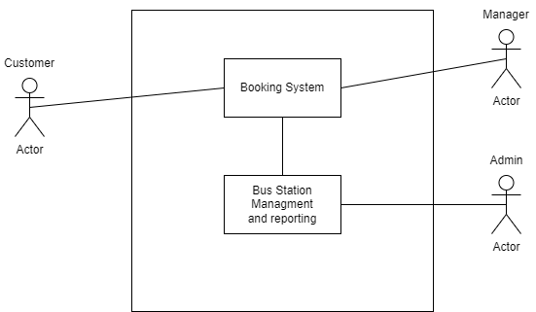

The Transportation system has three active actors and one cooperating system. The Customer and Bus Station Manager access Booking System. Admin can manage Bus Stations and generate Reports.

*3.2 Functional Requirements Specification*

3.2.1 Customer Use Case

**Diagram:**

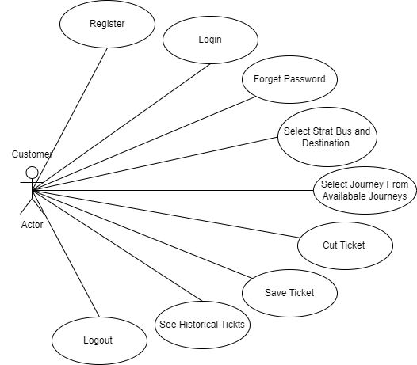

**Use Case: Register**

**Diagram:**

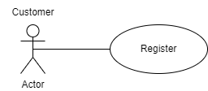

**Brief Description**

The customer can register an account using some data such as: name, number, email, and password.

**Initial Step-By-Step Description**

Before this use case can be initiated, the Customer has already accessed the application and click on Sign up.

1. Customers choose to sign up from the sign in page.
2. The system display form through it, the Customer can enter his data.
3. The data required to register is Name, Phone Number, Email, and Password.
4. The system sends verify code to Phone Number.
5. The system display page that customer can enter the verify code.
6. After successfully registering, the system displays the Main Page.

**Use Case: Login**

**Diagram:**

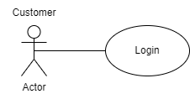

**Brief Description**

The customer can login using email and password so he can access the application functionality.

**Initial Step-By-Step Description**

Before this use case can be initiated, the Customer has already signed up and already has an account.

1. Customer enters data required to Login page (email and password).
2. System validates the data.
3. After successful login, customers can access the application functionality.

**Use Case: Forget password.**

**Diagram:**

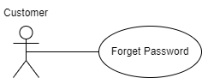

**Brief Description**

The customer can reset the password when he forgets it using email.

**Initial Step-By-Step Description**

Before this use case can be initiated, the Customer has already accessed the Transportation application.

1. Customers choose to forget password from the sign in page.
2. Customers enter his account email.
3. The system sends verify code to Phone Number.
4. The system display page that customer can enter the verify code.
5. After successfully verifying, the display reset password page.
6. After successfully resetting the password, the system displays the Login page.

**Use Case: Select Start and Destination**

**Diagram:**

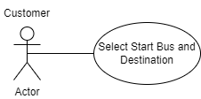

**Brief Description**

The customer can select Start bus Station and Destination bus Station to see the available journey.

**Initial Step-By-Step Description**

Before this use case can be initiated, the Customer has already Signed in, and he has accessed the Mai Page.

1. The customer can select Start bus Station and Destination bus Station.
2. When the customer clicks on the Search button, the system will display the page that contains the available journey.

**Use Case: Select Journey**

**Diagram:**

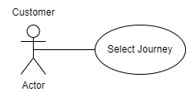

**Brief Description**

The customer can select the journey based on the start and destination that he has selected.

**Initial Step-By-Step Description**

Before this use case can be initiated, the Customer has already selected the Start and Destination Bus Station.

1. The system will display the available journeys based on Start and Destination Bus Station.
2. Every journey display data such as: (Start Bus, Destination Bus, leaving time and Number of Tickets Remaining)
3. Customer can Search Again (Button) to refresh the page.
4. When customer select specific journey, the system will display page to cut Ticket.

**Use Case: Cut Ticket**

**Diagram:**

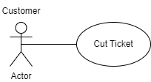

**Brief Description**

The customer can cut tickets based on the journey he has selected.

**Initial Step-By-Step Description**

Before this use case can be initiated, the Customer has already selected the journey.

1. The System displays page contains available seats.
2. Customers select an available seat and book it.
3. After successfully booking, the system will display the ticket.

**Use Case: Save Ticket**

**Diagram:**

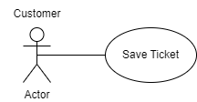

**Brief Description**

The customer can save the ticket after booking it.

**Initial Step-By-Step Description**

Before this use case can be initiated, the Customer has already Booked Ticket.

1. The System displays page contains the ticket he has booked.
2. Customer can save ticket (download it as image).
3. Customer can go to Main Page (With or without saving ticket).

**Use Case: See Historical Tickets**

**Diagram:**

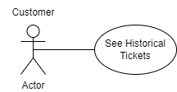

**Brief Description**

The customer can see all the historical tickets he has booked.

**Initial Step-By-Step Description**

Before this use case can be initiated, the Customer can access the historical tickets from menu list.

1. The System displays page contains all historical tickets.
2. When the customer leaves form historical tickets page, he returns to the page which he was on before he enters the historical tickets page.

**Use Case: Log Out.**

**Diagram:**

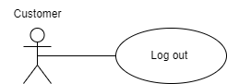

**Brief Description**

The manager can log out from the system.

**Initial Step-By-Step Description**

Before this use case can be initiated, the Customer has already logged in to the system (as Customer).

1. Click on the Logout navigation button from the navigation bar.
2. The system Logged the account out and returned the Customer to login page.

*3.2.2**Bus Stop Manager Use Case*

**Diagram:**

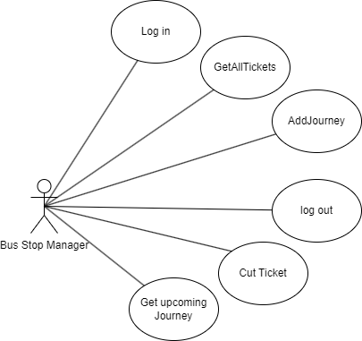

**Use Case: Log in.**

**Diagram:**

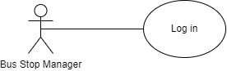

**Brief Description**

The customer can login using email and password so he can access the application functionality.

**Initial Step-By-Step Description**

Before this use case can be initiated, the manger has accessed the transportation website (for manager) and has email and password.

1. Manager enters data required to Login page (email and password).
2. System validates the data.
3. After successful login, manager can access the application functionality.

**Use Case: Add Journey.**

**Diagram:**

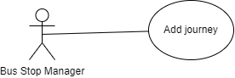

**Brief Description**

The manager can add new journey to the system.

**Initial Step-By-Step Description**

Before this use case can be initiated, the manager has already logged in to the system (as manager) and clicked on the add journey navigation button.

1. Manager enters data required for adding form (Destination bus stop, Bus Id, Ticket Price, Arrival Time, Leaving Time).
2. System validates the data.
3. The system displays success Message on screen.

**Use Case: Get All Tickets.**

**Diagram:**

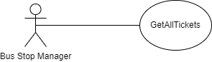

**Brief Description**

The manager can get his history of cut tickets.

**Initial Step-By-Step Description**

Before this use case can be initiated, the manager has already logged in to the system (as manager)

1. Click on All Tickets navigation button from the navigation menu.
2. All Tickets Display on screen.

**Use Case: Get Upcoming Journey.**

**Diagram:**

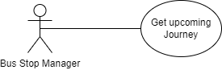

**Brief Description**

The manager can get a specific upcoming journey.

**Initial Step-By-Step Description**

Before this use case can be initiated, the manager has already logged in to the system (as manager)

1. Click on journeys navigation button from the navigation menu.
2. All journeys appear on screen.
3. Select journey from the journeys by clicking on cut button in the journey component.
4. All the details of the journey are displayed on a new screen.

**Use Case: Cut Ticket.**

**Diagram:**

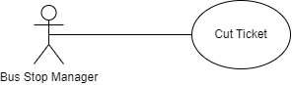

**Brief Description**

The manager can cut new tickets for the consumers.

**Initial Step-By-Step Description**

Before this use case can be initiated, the manager has already logged in to the system (as manager) and already select a journey.

1. Select an available seat from the seats displayed on seats component.
2. Click on the Cut button.
3. A new screen displays the generated ticket.

**Use Case: Log Out.**

**Diagram:**

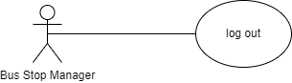

**Brief Description**

The manager can log out from the system.

**Initial Step-By-Step Description**

Before this use case can be initiated, the manager has already logged in to the system (as manager).

1. Click on the Logout navigation button from the navigation bar.
2. The system Logged the account out and returned the manager to login page.

*3.2.3 Admin Use Case*

**Diagram:**

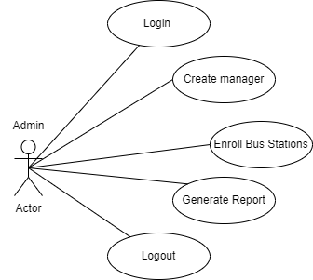

**Use Case: Login**

**Diagram:**

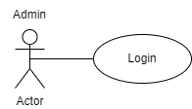

**Brief Description**

The admin can login using email and password.

**Initial Step-By-Step Description**

Before this use case can be initiated, the admin has accessed the transportation website (for admin) and has email and password.

1. Admin enters data required to Login page (email and password).
2. System validates the data.
3. After successful login, manager can access the website functionality.

**Use Case: Create Manager.**

**Diagram:**

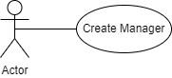

**Brief Description**

The admin can create an account for the Bus Station Manager.

**Initial Step-By-Step Description**

Before this use case can be initiated, the admin has already logged in the transportation website (for admin) and clicked on create manager navigation button.

1. The system displays the page contains form through it, the admin can enter the data.
2. The required data for creating manager is: (Email, Name, Password and Confirm Password).
3. After successfully creating manager, the system displays message with successful creating.

**Use Case: Enroll Bus Station to Another.**

**Diagram:**

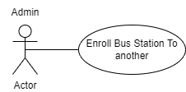

**Brief Description**

The admin can enroll bus station to another to have journeys between them.

**Initial Step-By-Step Description**

Before this use case can be initiated, the admin has already logged in the transportation website (for admin) and clicked on enroll navigation button.

1. The system displays the page contains form through it, the admin can select the bus stops from it.
2. Admin select the start bus stop from start bus stops drop down list
3. Not-related destination bus stops loaded throw the destination drop down list.
4. Admin selects the destination bus stop from the destination drop down list.
5. Click on the Enroll button in the form.
6. System displays success message on screen.

**Use Case: Generate Reports.**

**Diagram:**

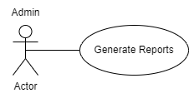

**Brief Description**

The admin can see dashboard to Facilitate data-driven decision-making.

**Initial Step-By-Step Description**

Before this use case can be initiated, the admin has already logged in to the transportation website (for admin) and clicked on dashboard navigation button.

1. Reports can be generated on topics like:

* # Buses.
* # Journeys.
* # Tickets.
* Profit sum.
* # Journeys and # tickets by start bus name.
* # Ticket by date.
* # Journeys by date.
* Profit sum by start bus name.
* Profit sum by date.
* Profit sum by reserved online or not.
* CV_profit by date.
* # Destination for each start-by-start bus name.

**Use Case: Log Out.**

**Diagram:**

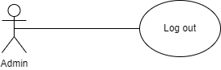

**Brief Description**

The admin can log out from the system.

**Initial Step-By-Step Description**

Before this use case can be initiated, the admin has already logged in to the system (as admin).

1. Click on the Logout navigation button from the navigation bar.
2. The system Logged the account out and returned the admin to login page.

*3.3 Non-Functional Requirements*

1. Performance: Application Should Load quickly and provide smooth user Experience.

2. Security: Application should be secure different functionalities in server sides based on the role of the user, so:

* admin can only access admin’s functions such as:
* login as admin
* create manager.
* Manager can only access manager functions such as:
* create journeys.
* cut tickets.
* user can only access consumer’s functions such as:
* login
* Register
* book tickets.

Some different points should be clear:

* Ui is separated for manager UI, Admin UI, and consumer UI so no one can access the functionalities of another role.
* Consumer account cannot login as admin or manager, same thing on each role.

3. Usability: Application should be user-friendly so it will be easy for each user for the system (consumer, admin, and manager) to deal with it.

4. Maintainability: Application should be easy to maintain with clear documentation and well-           organized code.

5. Availability: the application should always be available for all users with minimal down times.

6. Scalability: Application should accommodate changes and growth so it will be easy to develop in case more Users use the application.

**4.0 Feasibility Studies**

*4.1 Introduction:*

The Transportation system is purposed to make the movement from place to another specified and given to it better quality than the public transportation system.

*4.2 Objectives:*

The primary objectives of the Transportation System are:

Give the users of our website and application the best and available quality of the transport with a Reasonable amount for our users 

*4.3 Technical Feasibility:*

The Bus Stop Management System would require the implementation of various technologies, including:

 We used in this project 11 major objects:

* **Asp.net**
* **Seri log**
* Entity Framework
* Hang fire.
* LINQ
* Api
* Angular
* Flutter
* SQL server
* SSIS
* Power BI

*4.4 Economic Feasibility:*

               The Bus Stop Management System would require some Costs like:

* **App Development and Maintenance:** Creating and maintaining a user-friendly and efficient mobile app is an ongoing cost.
* **Marketing and User Acquisition:** Attracting both drivers and riders requires marketing efforts, which can be expensive.
* **Payment Processing Fees:** Transaction fees for credit card payments and other methods.

               It would have some benefits like:

* **Commissions on Fares:** Booking systems typically take a commission on each fare paid by the rider.
* **Advertising Revenue:** In-app advertising or partnerships with businesses can be a revenue stream.
* **Additional Considerations:**
* **Technology Integration:** Seamless integration with mapping services, payment gateways, and communication tools is crucial.
* **Data Security:** Protecting user data (payment information, location) is critical for building trust.

**Overall, a** Bus Stop Management System **can be economically feasible if it can:**

* **Keep costs (app development, marketing, driver incentives) under control.**
* **Charge competitive fares with a healthy commission rate.**
* **Differentiate itself from competitors through features or pricing.**

*4.5 Operational Feasibility:*

**The implementation of the transportation system would have some operations to make and some things to make the system works:**

* **Resources:**    
  **enough people:** Every bus station must have at least one manager   
  **equipment:** Each bus stop must have at least one PC and it must be well connected to the Internet
* **Existing Processes:** The project implementation must fit in with the business Processes.
* **Legal and Regulatory Issues:** It will be legal.

**5.0 Diagrams**

*5.1 Sequence Diagram*

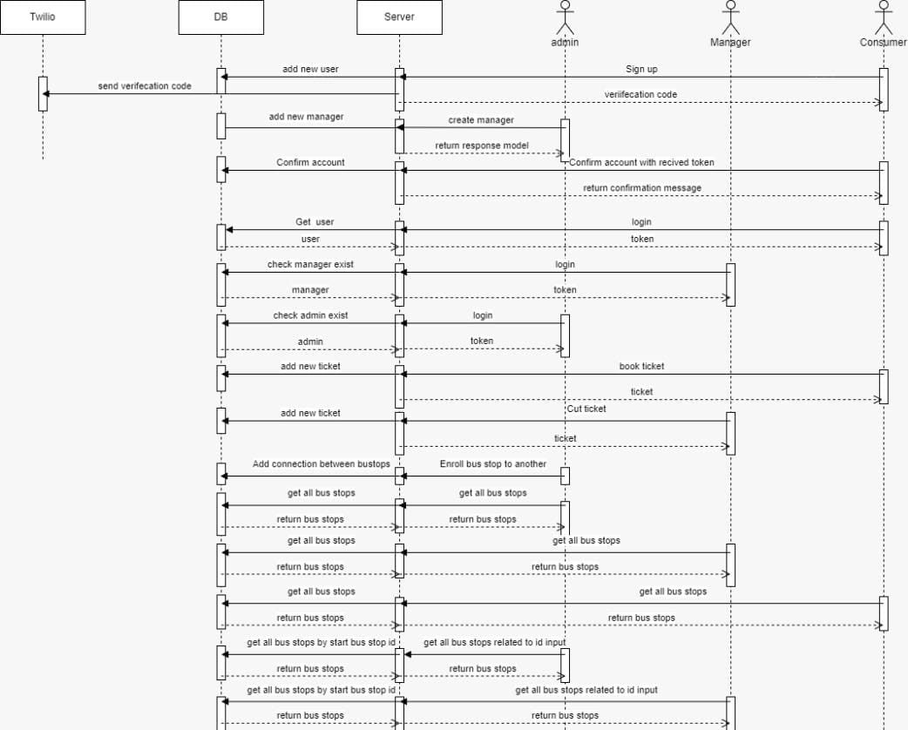

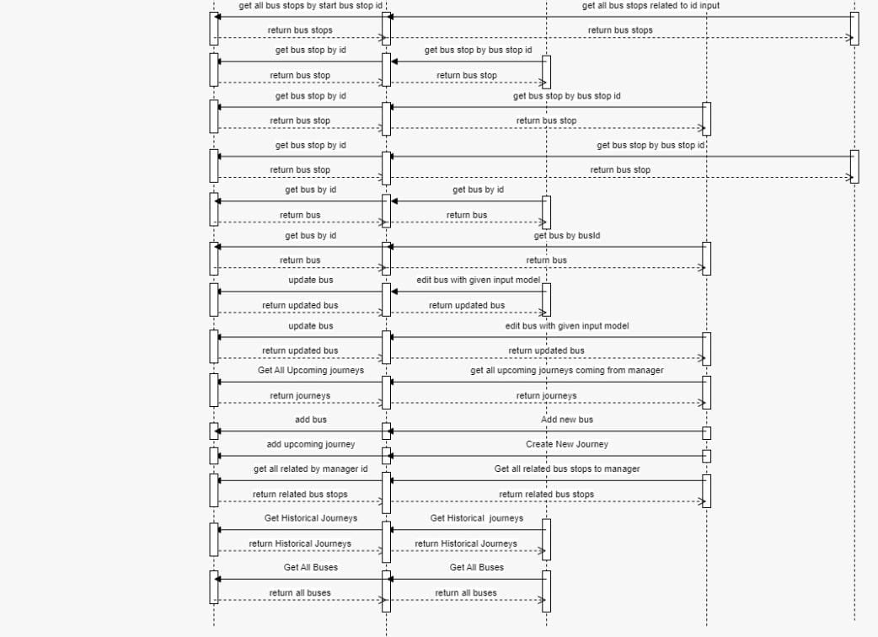

*5.2 Data Flow Diagram*

*5.2.1 context level*

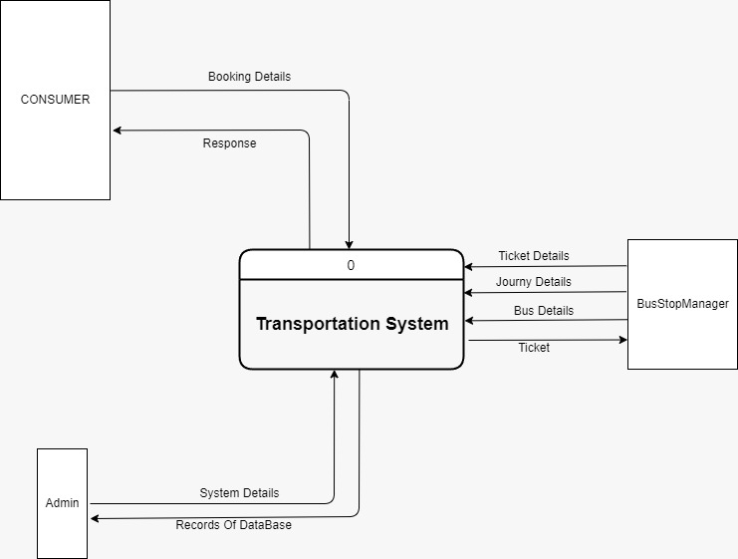

*5.2.2 level Zero*

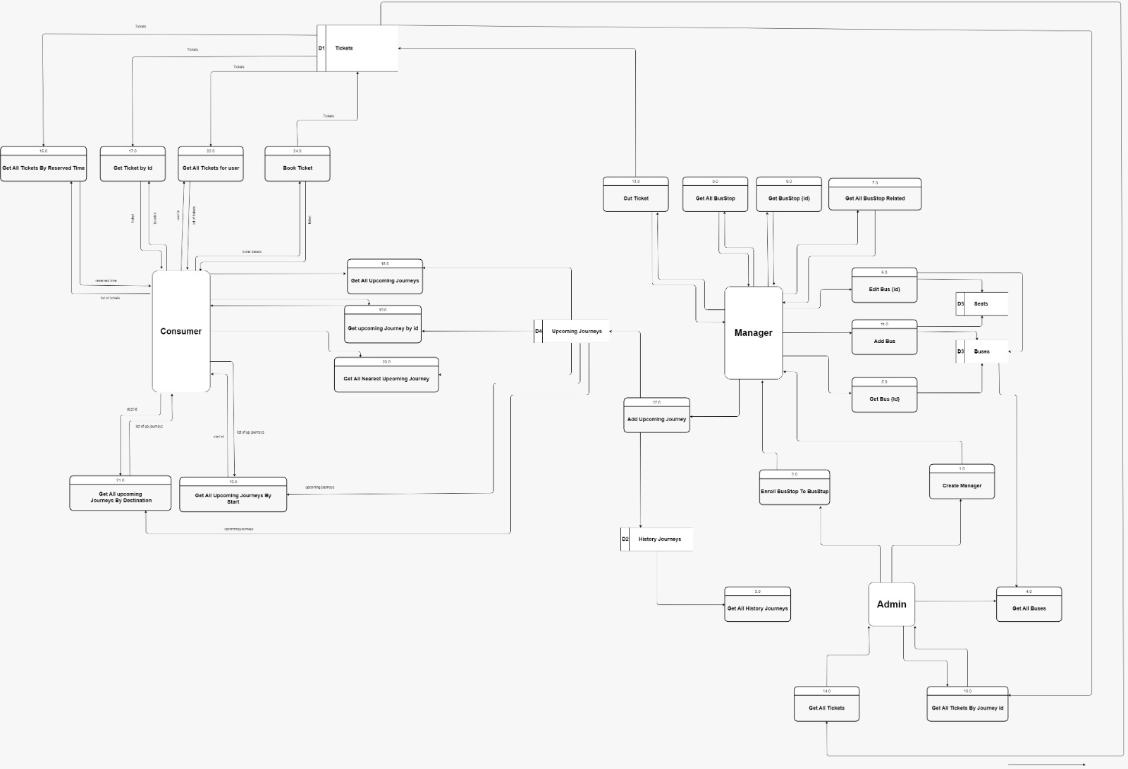

*5.2.3 Level One*

*5.2.3.1 Level One (Process 11)*

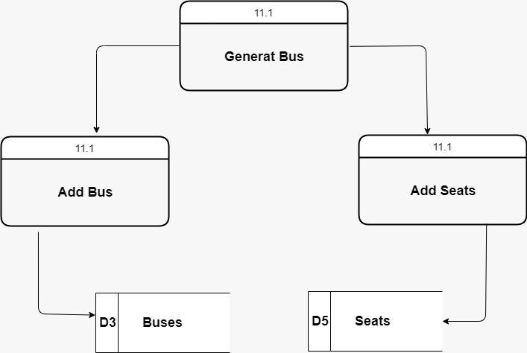

*5.2.3.2 Level One (Process 12)*

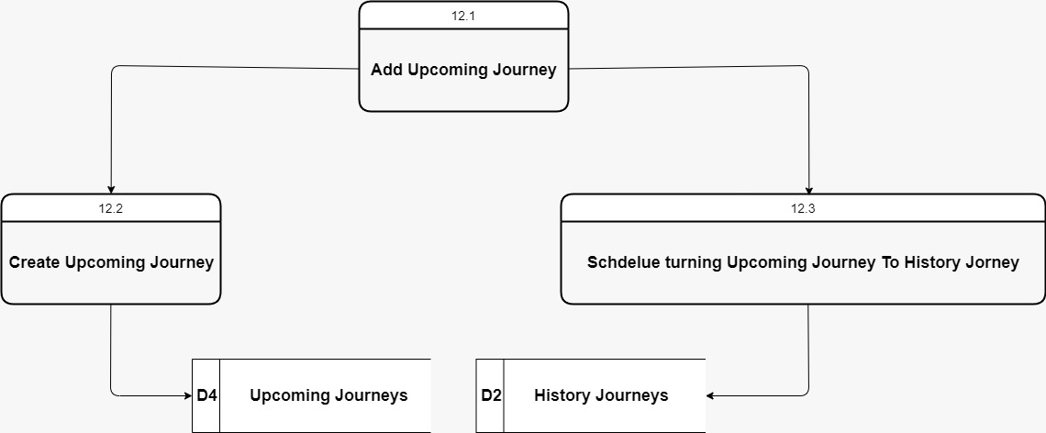

*5.2.3.3 Level One (Process 13)*

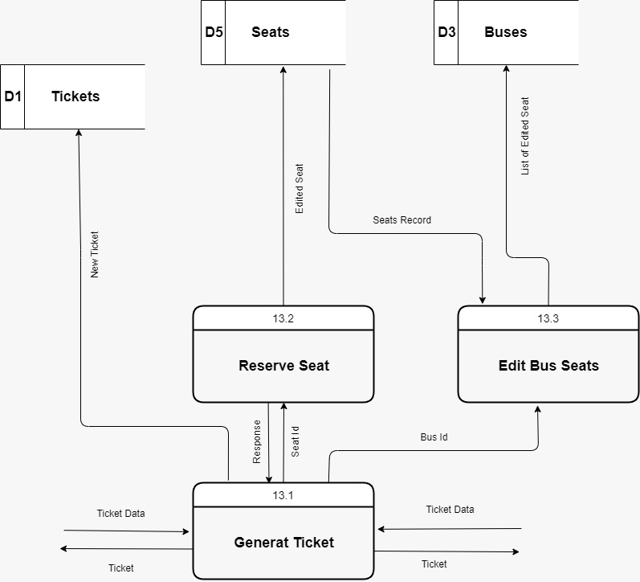

*5.3 Logical Modeling*

*5.3.1 Tree Diagram*

*5.3.1.1 Process 1*

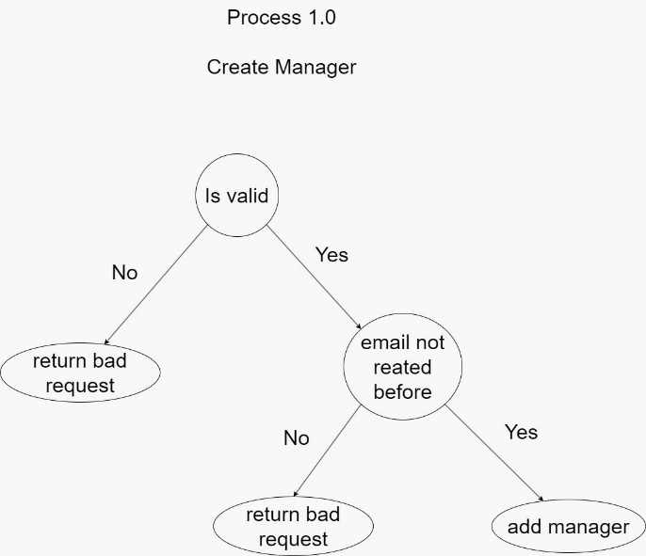

*5.3.1.2 Process 2*

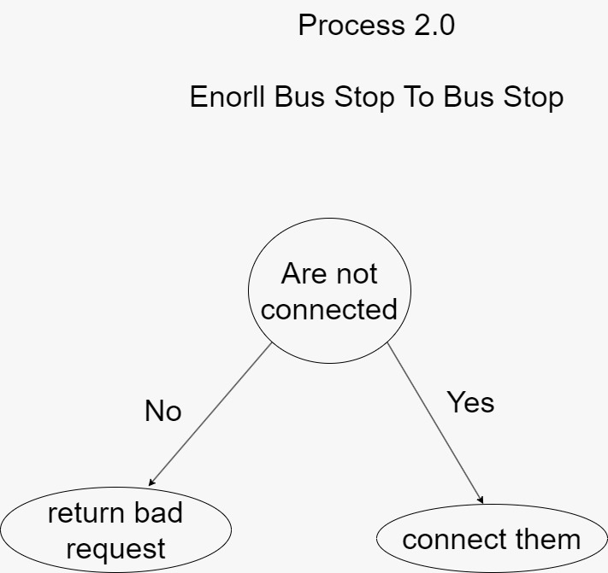

*5.3.1.3 Process 3*

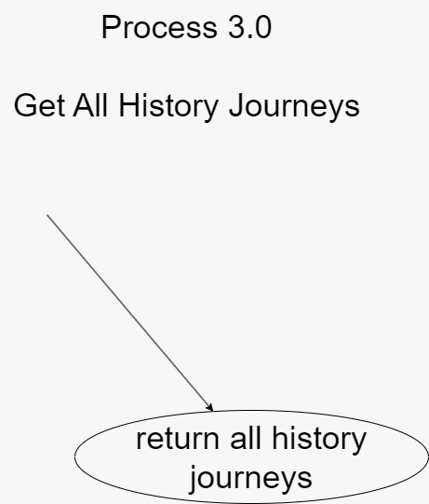

*5.3.1.4 Process 4*

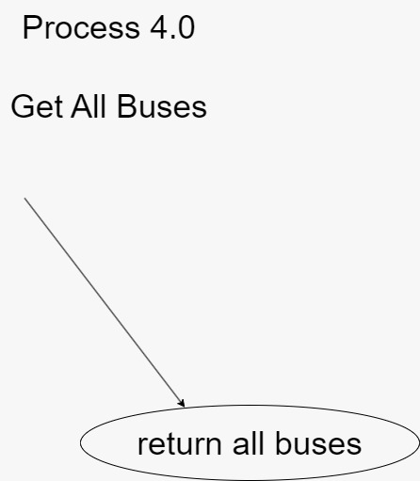

*5.3.1.5 Process 5*

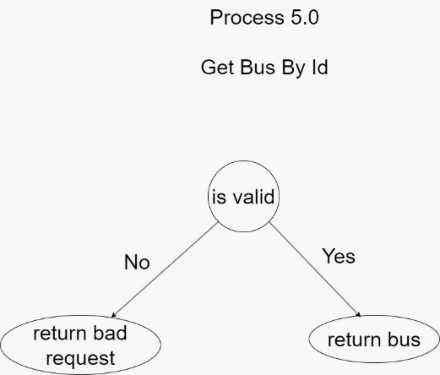

*5.3.1.6 Process 6*

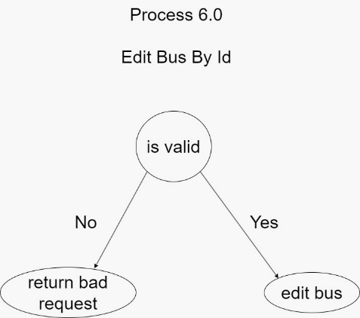

*5.3.1.7 Process 7*

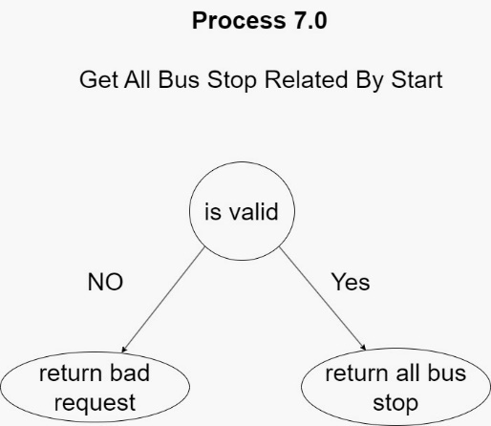

*5.3.1.8 Process 8*

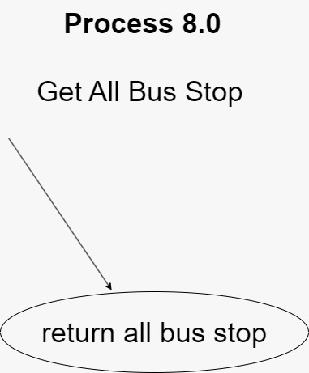

*5.3.1.9 Process 9*

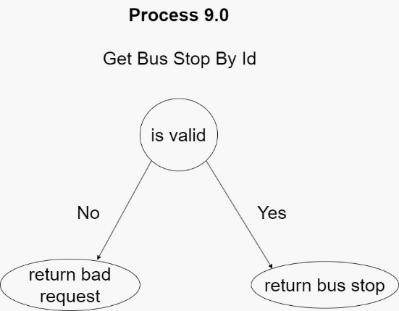

*5.3.1.10 Process 10*

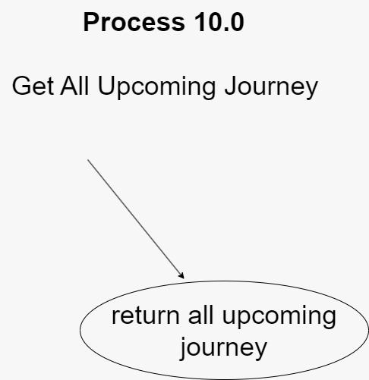

*5.3.1.11 Process 11*

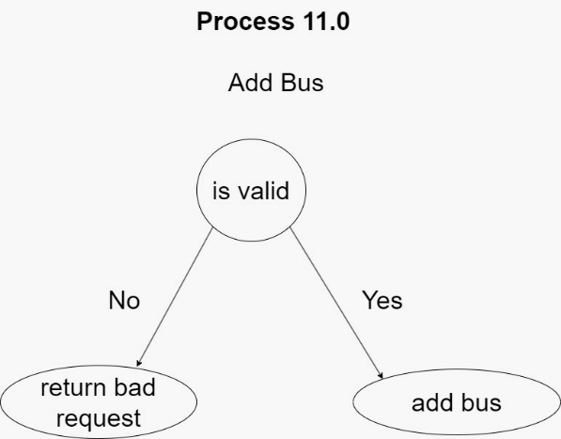

*5.3.1.12 Process 12*

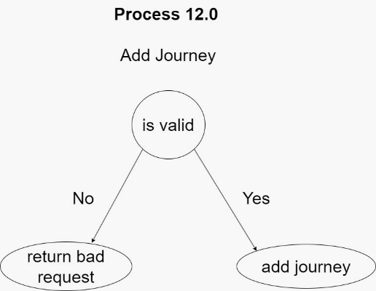

*5.3.1.13 Process 13*

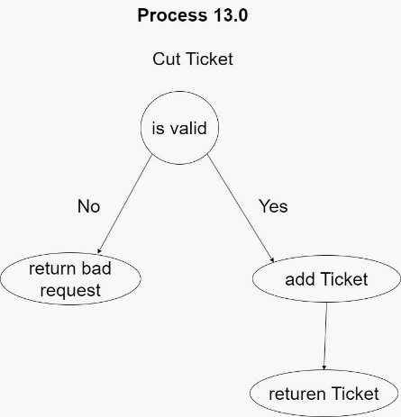

*5.3.1.14 Process 14*

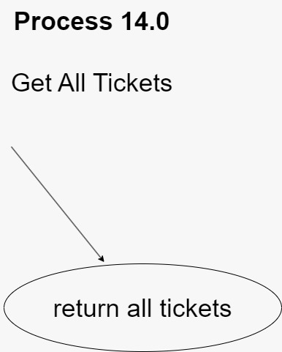

*5.3.1.15 Process 15*

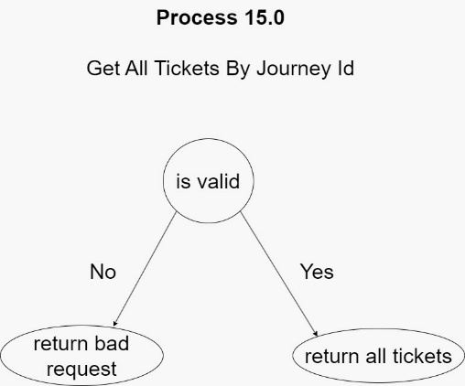

*5.3.1.16 Process 16*

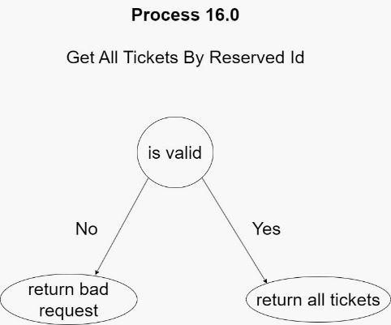

*5.3.1.17 Process 17*

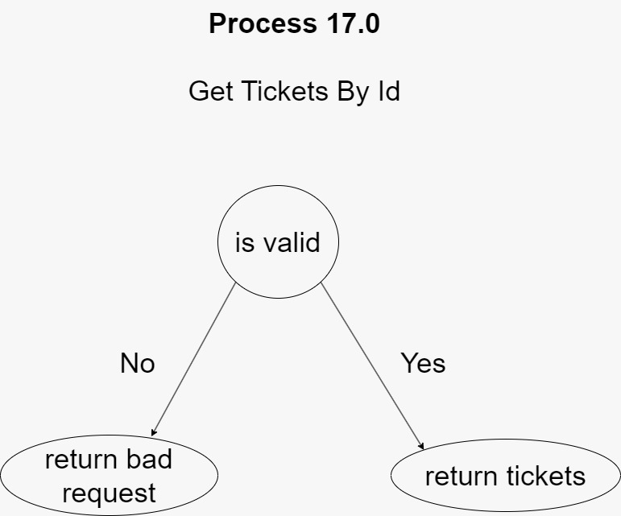

*5.3.1.18 Process 18*

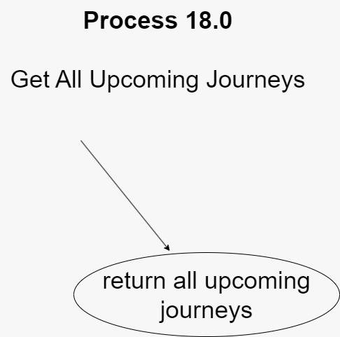

*5.3.1.19 Process 19*

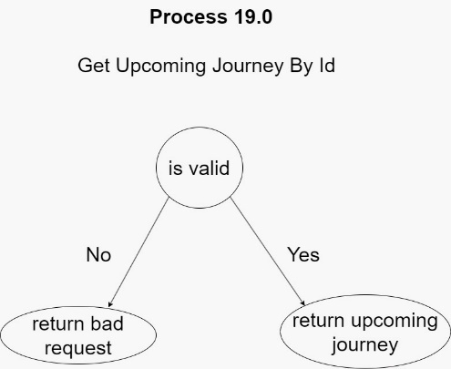

*5.3.1.20 Process 20*

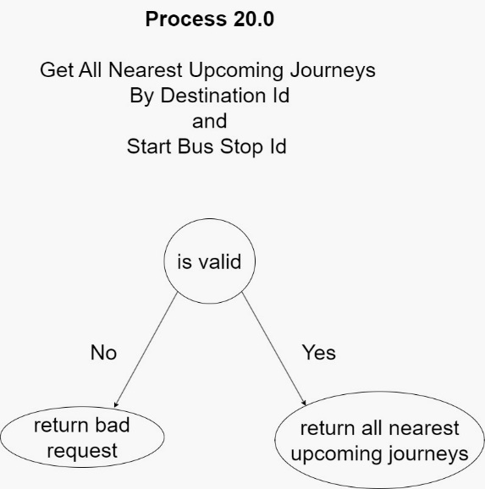

*5.3.1.21 Process 21*

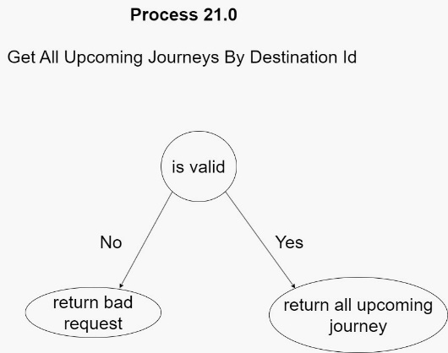

*5.3.1.22 Process 22*

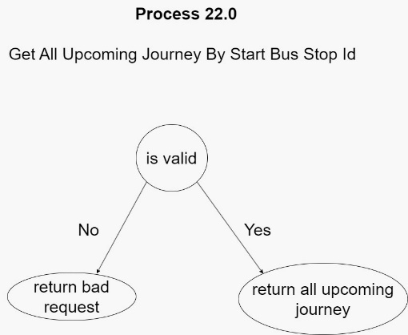

*5.3.1.23 Process 23*

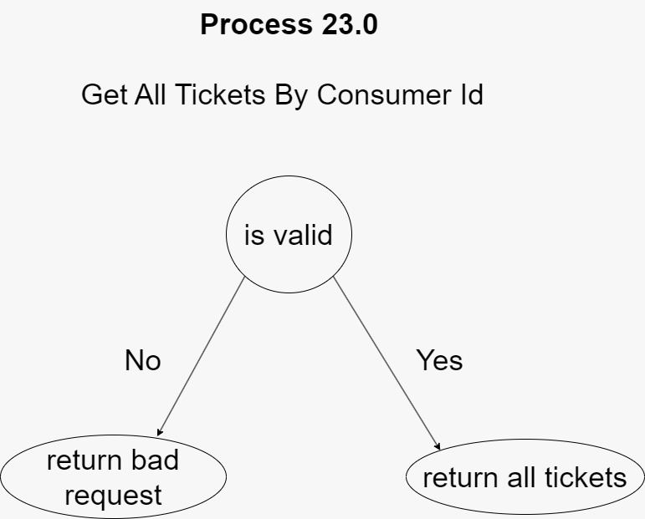

*5.3.1.24 Process 24*

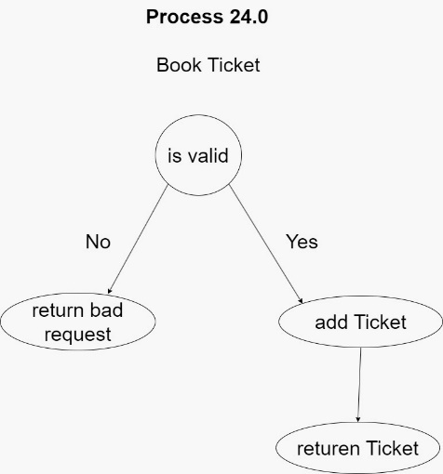

*5.3.1.25 Process 25*

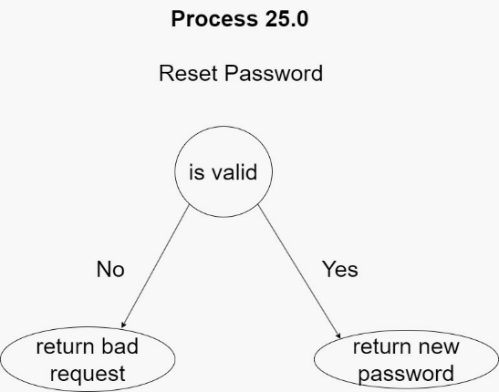

*5.3.1.26 Process 26*

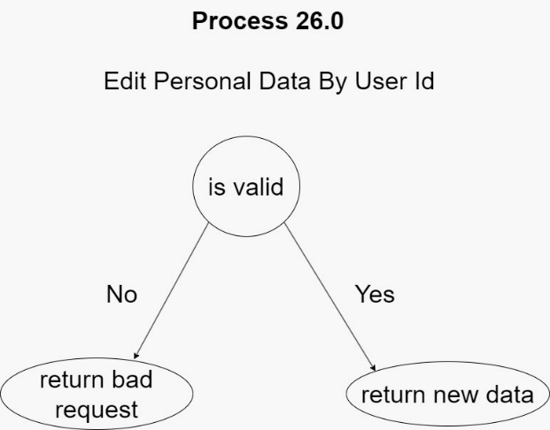

*5.3.2 Decision Table*

*5.3.2.1 Process 1:6*

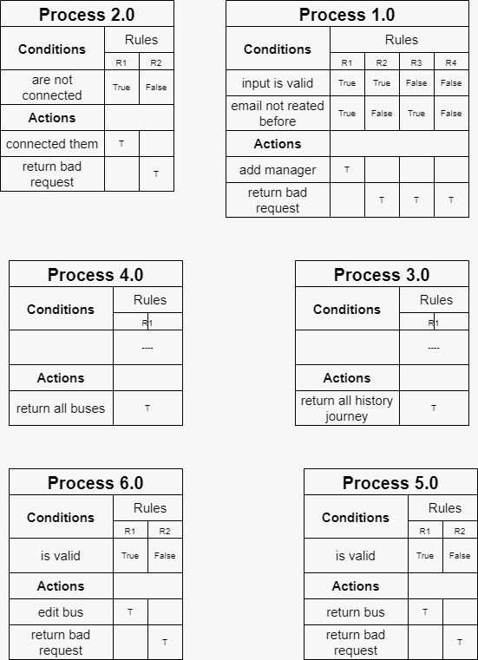

*5.3.2.2 Process 7:12*

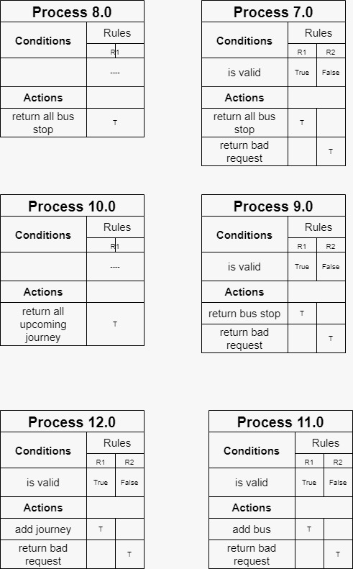

*5.3.2.3 Process 13:18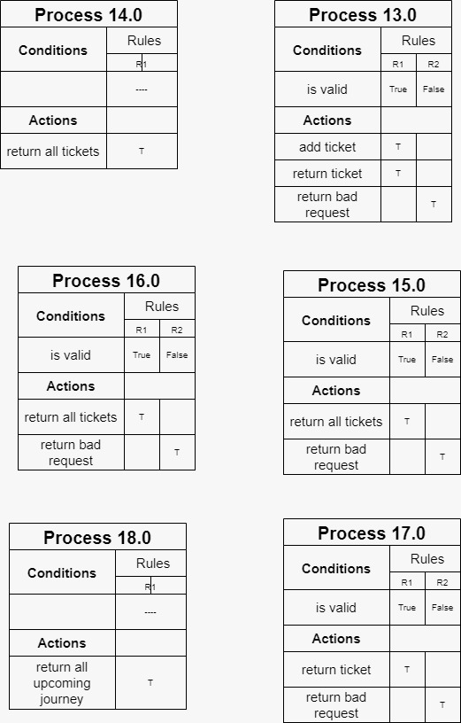*

*5.3.2.4 Process 19:25*

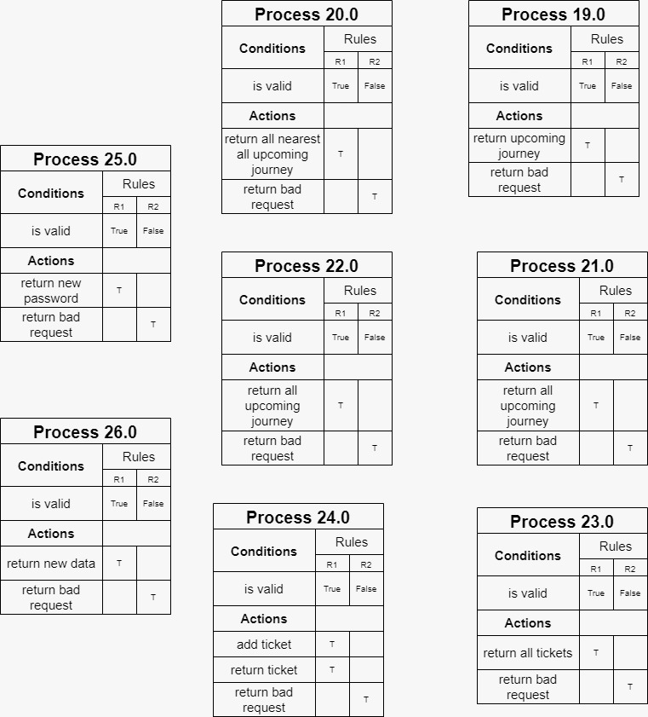

*5.3.3 English Structure*

*5.3.3.1 Process 1:6*

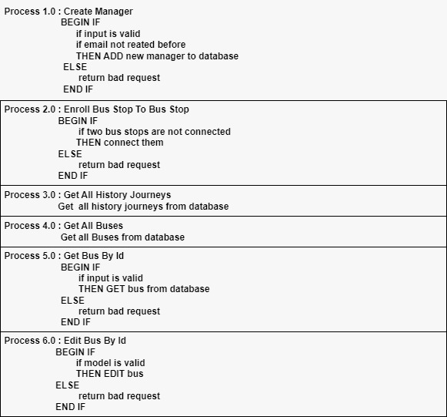

*5.3.3.2 Process 7:15*

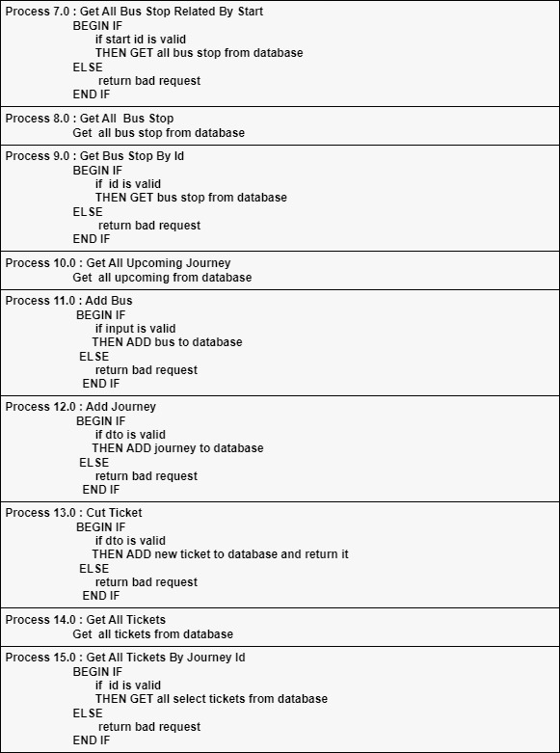

*5.3.3.3 Process 16:22*

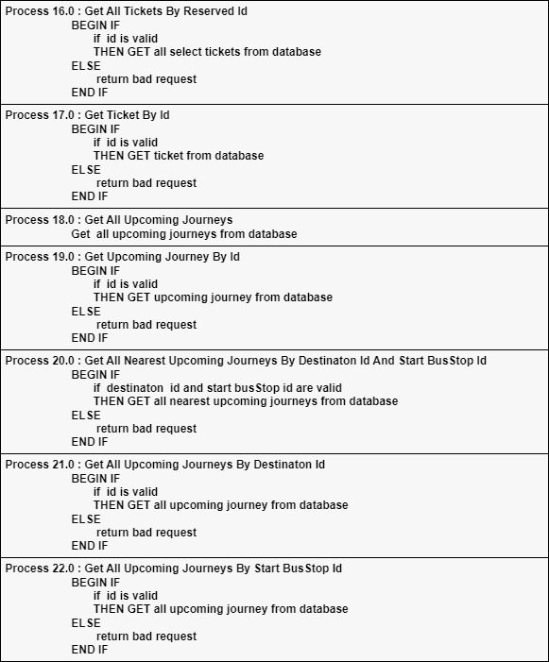

*5.3.3.4 Process 23:26*

